Mr.Jarst
if you do not have post-processing installed, then here is the instruction
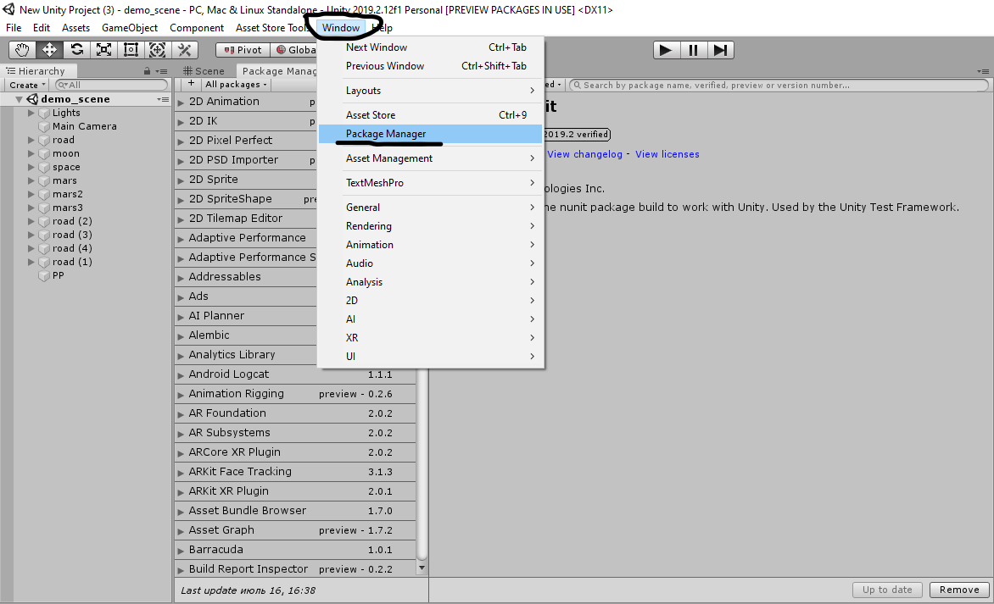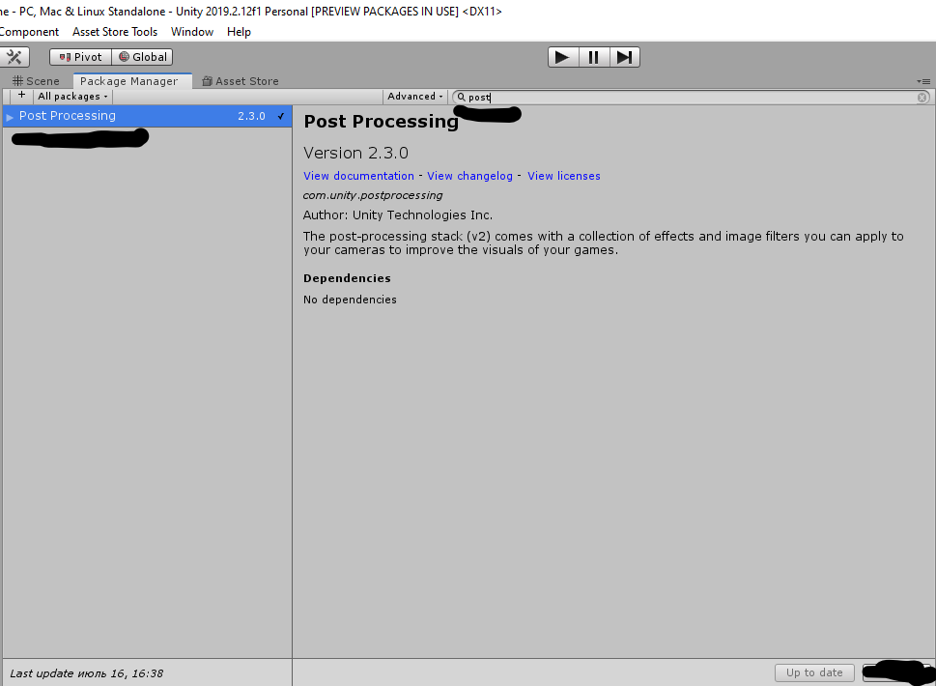
to achieve the look like in the screenshots, it is enough to set the following parameters:
PP- object in demo scene
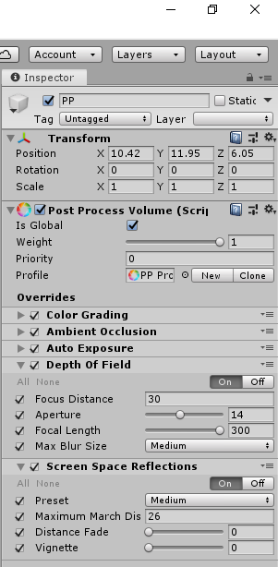
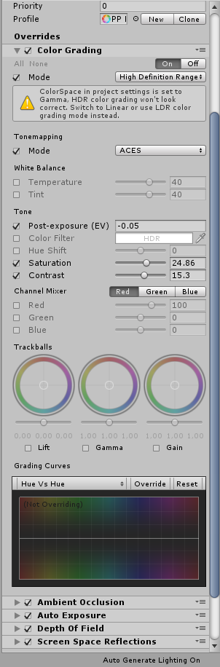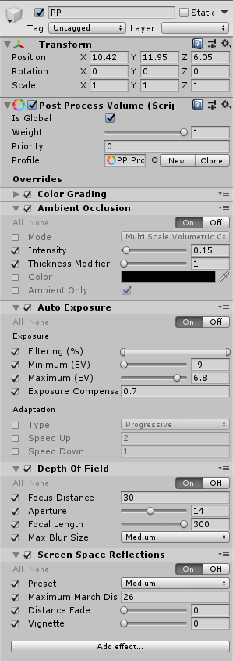

camera parameters
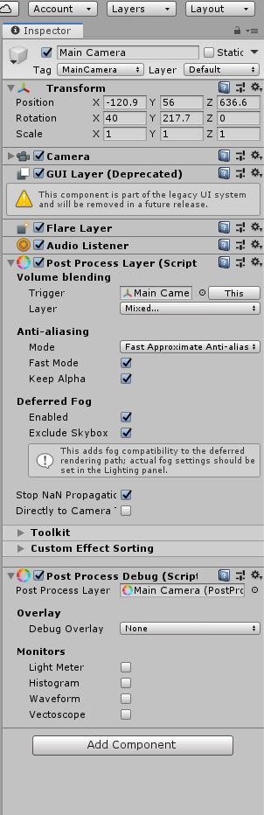

DIMENSIONS

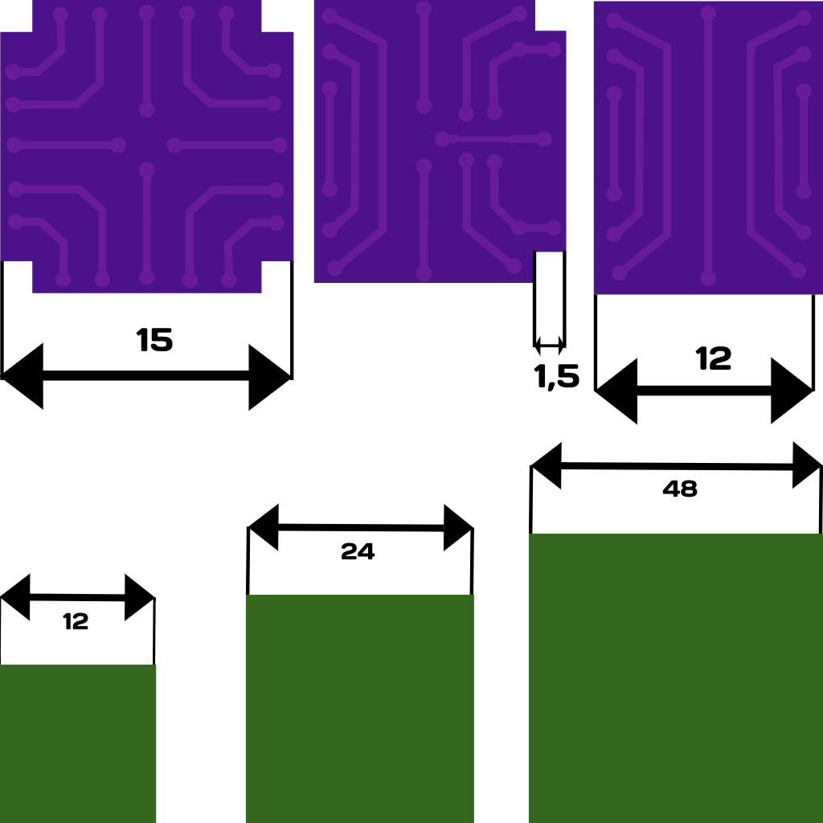

pleasant use

